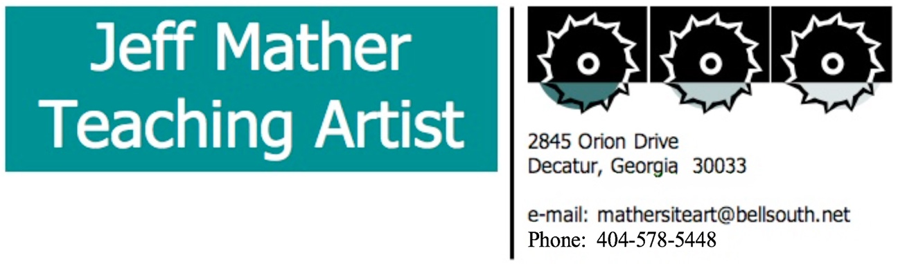

Jeff is a community-based public artist and multi-disciplinary teaching artist. He has conducted site sculpture residencies and directed public art projects all over Georgia. He is board president of the Atlanta Partnership for Arts in Learning (APAL). He is the STEAM Artist-in-Residence at Drew Charter School for 45 days each semester, where he co-teaches project-based learning units in K-12. His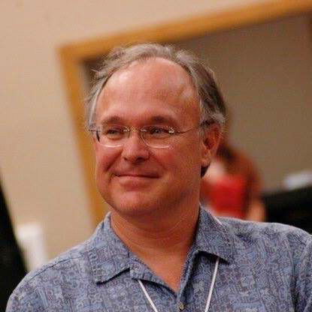 partnership work at Drew has been featured by GPB and Edutopia and has received two Innovations awards from the Governor’s Office of Student Achievement. Jeff was digital storytelling coach for nine years at the South Atlanta School of Law and Social Justice and he has created digital storytelling programs for the Woodruff Art Center, for APAL, and at Drew Charter. He has directed experimental theater productions at the Center for Puppetry Arts and served as artist-in-residence for the Atlanta Symphony and the High Museum. Jeff has served as an artist-in-residence at over 1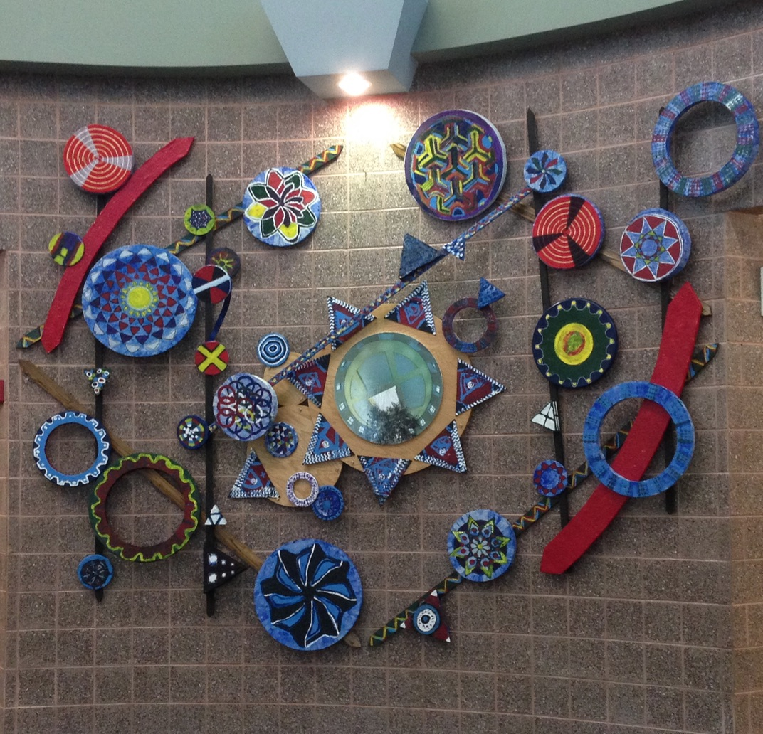50 schools.

**Arts Infusion partnerships:** As a leader in the teaching artist field and in the burgeoning STEAM Ed and Maker Ed fields, Jeff has been a partner for educators in all subject areas and all grade levels at various points. He has designed and facilitated PD retreats for teachers and teaching artists and coached the formation of arts infusion partnerships in Georgia, Alabama, and Utah. During the 2017-18 school year, Jeff ran an arts infusion residency at Westchester School in Decatur that was co-designed with the art teacher and the three third grade teachers that focussed on water sustainability and resulted in an environmental sculpture by the side of the creek that runs alongside the school’s campus. Also in 2018, in addition to his ongoing STEAM residency at Drew Charter, Jeff was STEAM Artist-in-Residence for the Baldwin County School System in Milledgeville for three weeks and at the Academy of Academics and Arts in Huntsville, Alabama for three weeks.