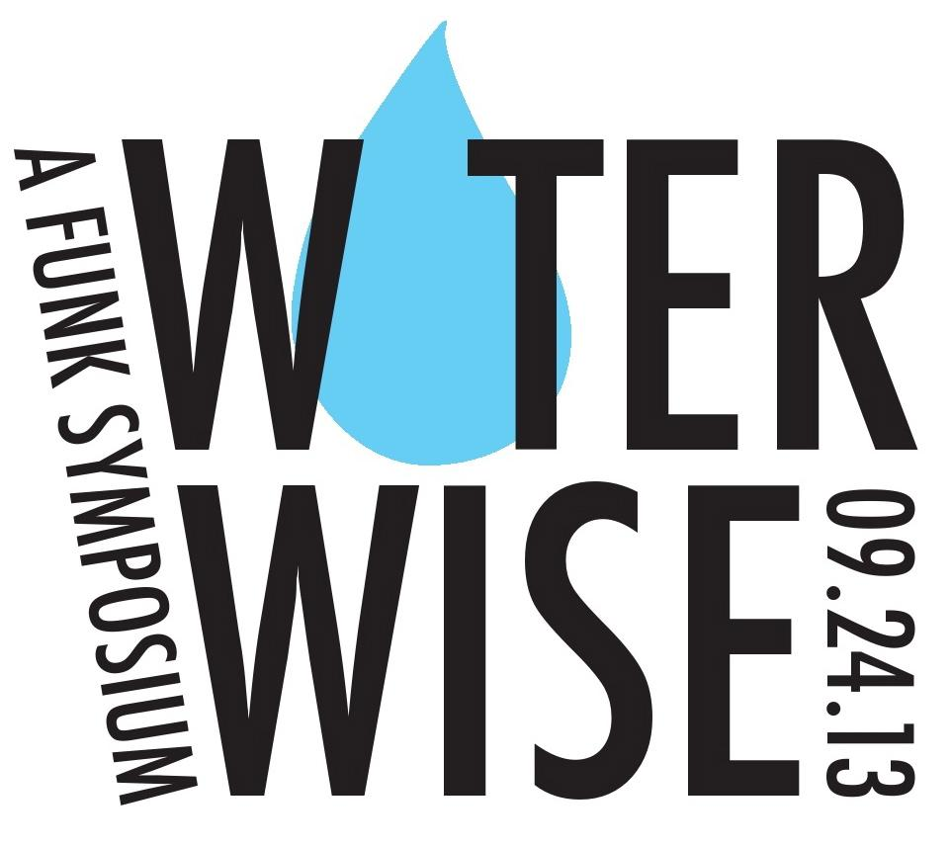
Presented by The Decatur Education Foundation

A One-Day Symposium for 8th and 9th Grade Students of City Schools of Decatur

Call for Workshop Proposals

The Decatur Education Foundation, in partnership with City Schools of Decatur International Baccalaureate (IB) program, is pleased to announce Water Wise, a Funk Symposium. Water Wise is an educational opportunity provided to all 8th and 9th grade students enrolled in City Schools of Decatur, intended to explore global water issues through multiple perspectives.

The symposium will offer a menu of break out sessions. Presenters will provide interactive and discussion- based sessions on global water issues

Sessions must be age appropriate and geared toward participants 13-15 years old. Sessions should be interactive and have an element of discussion. Session leaders must be prepared to lead two morning sessions. Presenters will be done with morning sessions by 12:00 PM but are welcome to stay for lunch and the afternoon program.

The Water Wise keynote address will be presented by Evan Abramson and Carmen Elsa Lopez, documentary filmmakers whose multiple award-winning short film, Carbon For Water, explores an innovative solution to the water crisis and associated environmental crisis facing people in the Western Province of Kenya. See http://www.vestergaard-frandsen.com/carbon-for-water-film/filmmakers.html for details.

PLEASE TYPE AND EMAIL THIS FORM TO amanda@decatureducationfoundation.org
BY March 15, 2013. Use additional space as needed.
Questions? Contact Amanda Dean, 404-432-2351

Name of Presenter: ___________________________________________________

Email:_______________________________ Phone Number:_________________

Affiliation and Job Title: _______________________________________________

Workshop Title: ______________________________________________________

Workshop Description: (workshops will be 55 minutes long)
Please limit your description to 50-75 words. Please accurately and concisely describe the content of your workshop.
_________________________________________________________________________
_________________________________________________________________________
_________________________________________________________________________
_________________________________________________________________________
_________________________________________________________________________
Workshop capacity (please choose the number of participants that would be best suited for your workshop)
- 15 -20
- 21-29
- 30-39
- 40+

What broader water theme does your workshop address?
(e.g., scarcity, contamination, conflict/war, historical, environmental, women and children, literary, religious or philosophical, etc.)

________________________________________________________________________

Narrative bio of presenter: (50-75 word maximum)
_________________________________________________________________________
_________________________________________________________________________
_________________________________________________________________________
_________________________________________________________________________
_________________________________________________________________________
_________________________________________________________________________
_________________________________________________________________________

Technology and room needs
Please indicate any technology needs. All classrooms at Renfroe Middle School have an ActivBoard and built-in projector as well as an iMac. You are welcome to bring your own computer (please indicate that below). _________________________________________________________________________
_________________________________________________________________________
_________________________________________________________________________
_________________________________________________________________________
_________________________________________________________________________
_________________________________________________________________________

Please list all materials or handouts you plan to use (please plan to provide to provide enough copies for your sessions) _________________________________________________________________________
_________________________________________________________________________
_________________________________________________________________________

How did you hear about the symposium? _____________________________________

The mission of the Decatur Education Foundation is to nurture and support academic achievement and enrichment opportunities for all the children and youth of Decatur.

